Project Explanations
Experiment : Verification of Nortan’s Theorem

Objective
To verify Nortan’s Thorem by measuring full load current.

Procedure (Steps)
- Measurement of Original Load Current (IL)
Objective: To find the actual current flowing through the load resistor in the complex circuit.
  - Procedure: A DC voltage source was set to 15V. Three 330ohm resistors and one 1K load resistor RL were connected in a bridge-T configuration. A DC Ammeter (set to mA range) was placed in series with the 1Kresistor.
  - Observation: The ammeter measured the current IL, which serves as our reference value to verify Norton's Theorem

Determination of Norton Current (IN)
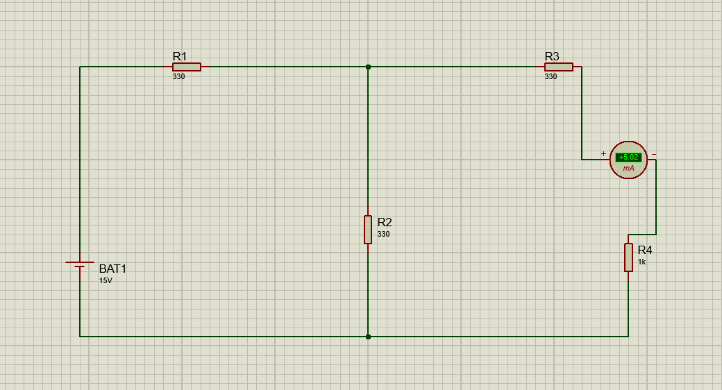
Objective: To find the short-circuit current of the network.

  - Procedure: The 1K load resistor was removed from the circuit. The output terminals (where the load was) were "short-circuited" by connecting a DC Ammeter directly across them.

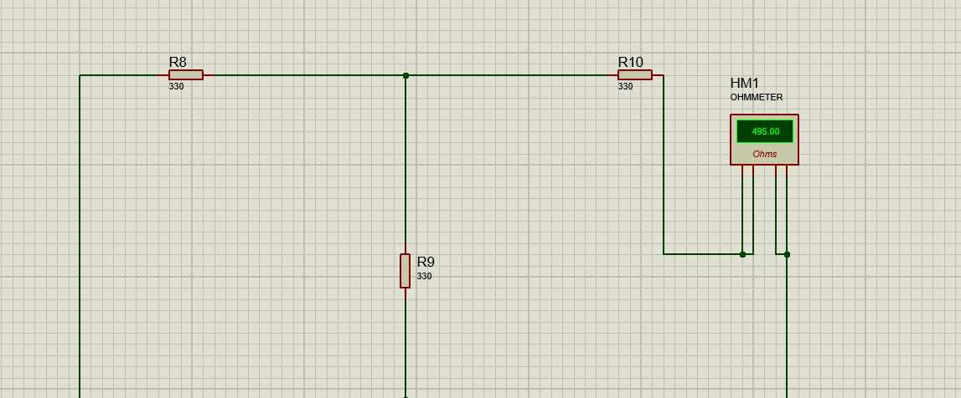
  - Observation: The current recorded on the ammeter is the Norton Current IN. This represents the maximum current the circuit can provide when the load resistance is zero.
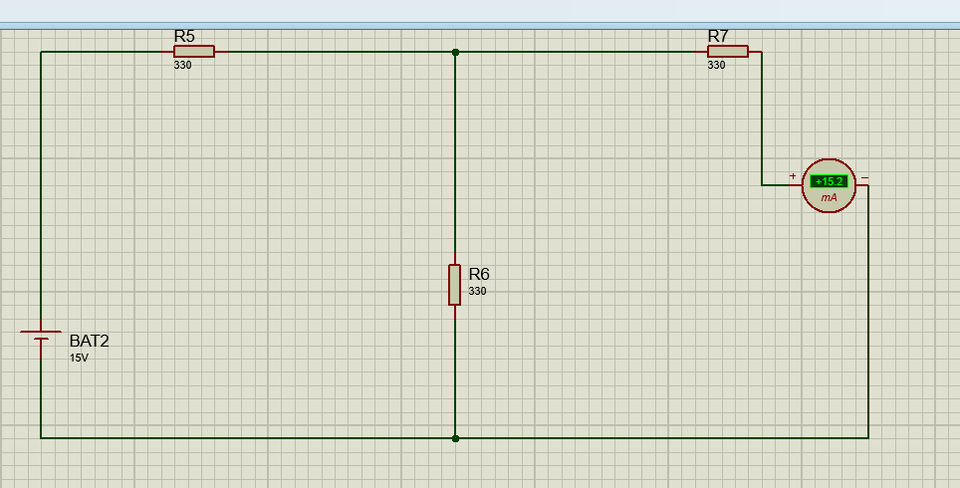

Determination of Norton Resistance (RN)
Objective: To find the equivalent internal resistance of the network.

  - Procedure: The 15V source was replaced with a short circuit (its internal resistance). The load remained disconnected. An Ohmmeter was connected across the open load terminals.
  - Calculation: Theoretically, we verified this by calculating the parallel combination of the first two 330 ohm resistors and adding the third:

Norton Equivalent Circuit Verification
Objective: To prove that a single current source and one parallel resistor produce the same IL as the original complex circuit.
  - Procedure: A CSOURCE (Current Source) was placed and set to the IN value found in step 2 (15.15mA). A single resistor representing RN(495 ohm) was connected in parallel with the current source. Finally, the original 1K ohm load was connected in parallel to this combination.
  - Observation: The ammeter in series with the 1k load showed a current of 5.02mA, which matched the IL from the original circuit, thereby verifying Norton's Theorem
